Literary Descriptions and Narratives
Outcomes
WS2.9 Drafts, revises, proofreads and publishes well-structured texts that are more demanding in terms of topic, audience and written language features. | Joint and Independent Writing  - uses other texts as models for aspects of writing such as text organisation, grouping of information under headings  - identifies key words and phrases  - uses some effective planning strategies  - demonstrates self-editing skills  - understands and creates notes for relevant writing purposes  - shows evidence of careful revision, editing and proofreading in final draft  - uses computers to draft and edit writing  - contributes to joint text-construction activities  - writes a wider range of text types  - structures text types in appropriate stages  - writes fuller descriptions of people, animals, objects, places  - writes more involved recounts  - writes longer, more complex procedures  - writes more extended descriptions of each feature in an information report  - writes information reports that include information about different parts of things and their components  - writes a range of literary texts  - writes simple poems  - writes simple sequential explanations  - writes simple responses to short stories, television programs  - expresses a point of view in writing with some supporting arguments  - writes questions and sends them by e-mail to an identified expert on a topic of interest  - creates simple hyperlinked text, eg HyperCard stack.
WS2.10 Produces texts clearly, effectively and accurately using the sentence structure, grammatical features and punctuation conventions of the text type. | Grammar and Punctuation  - builds word families in preparation for writing  - identifies nouns, verbs, adjectives and adverbs in own writing and how these add to the meaning of the text  - uses accurate tense and number in verb groups, eg they come, she comes  - uses present tense in factual texts such as information reports and procedures  - uses past tense in recounts and narratives  - combines clauses by using a variety of conjunctions, eg when, because  - uses a variety of time connectives in recounts and narratives  - uses conjunctions to construct cause–effect relationships, eg so, if, but, because  - uses modal verbs and adverbs in text types to indicate shades of meaning, eg possibility, probability, obligation  - identifies theme and beginning focus of clause and discusses how choice of theme affects meaning  - uses correct punctuation in published version of own writing, eg capital letters, full stops, question marks and commas uses apostrophes for contractions in written dialogue.
WS2.11 Uses knowledge of letter–sound correspondences, common letter patterns and a range of strategies to spell familiar and unfamiliar words. | Spelling  - spells high frequency words correctly in own writing  - uses known letter patterns when attempting to spell unknown words  - writes words containing less common digraphs and letter combinations  - uses knowledge of familiar letter patterns when attempting to spell unknown words  - identifies possible spelling errors in own writing, eg by circling or underlining doubtful words  - discusses strategies used for spelling difficult words  - deletes or adds words, adds information and rereads work to clarify meaning  - self-corrects words that do not look right  - uses spell check as one strategy for checking spelling.
WS2.13 Discusses how own texts are adjusted to relate to different readers, how they develop the subject matter and how they serve a wide variety of purposes. | Purpose  - talks about own writing  - uses the terms ‘drawing’ and ‘writing’ accurately  - indicates purpose of own writing  - recognises a range of text types, eg simple narrative, simple recount, simple procedure  - communicates the purposes of familiar written texts  - communicates the purposes of drawings, photographs and other graphic texts  - assists other children to locate print from models in classroom to use in writing.  Audience  • talks about the person to whom they are writing a message, eg friend, teacher, aunty.  Subject Matter  • talks about what they would like to write about with teacher prompt, eg pictures, school events.
WS2.14 Discusses how own texts have been structured to achieve their purpose and the grammatical features characteristic of the various text types used. | Text Structure  • recognises and discusses the organisational structure of a range of literary and factual texts.  Grammar  - recognises the subject, verb and object of a clause  - recognises different types of adverbial phrases and discusses how they give additional information  - identifies nouns, verbs, adjectives and adverbs in own writing and talks about their function in making meaning  - identifies action verbs and talks about how they are used in narrative and recount to develop a story  - talks about how different types of adjectives have been used to add information in own writing  - indicates how different types of verbs have been used in own stories, eg action verbs, saying verbs, thinking verbs, feeling verbs  - talks about the use of tense (past, present, future) in literary texts  - reviews own writing for use of noun groups in building information, eg in an information report  - recognises common errors in writing such as lack of agreement between subject and verb, eg he done it  - recognises theme of clauses (beginning focus for information), eg Kim opened the door.  Conventions  - talks about the use of commas, dashes etc to indicate the relationship between parts of sentences  - talks about the need to use quotation marks with quoted speech  - recognises and corrects the spelling of some common words.
WS2.12 Uses joined letters when writing in NSW Foundation Style and demonstrates basic desktop publishing skills on the computer. | Handwriting  - produces standard handwriting movements and patterns  - concentrates on lower-case and some upper-case letters  - holds writing implements in a way that allows them to make marks on the page  - tries to employ correct pencil grip  - maintains correct body position for writing  - starts at the top of every upper-case letter, lower-case letter and number, except ‘d’ and ‘e’ (which start in the middle) and knows that no letter starts from the bottom  - holds writing implement with only thumb, index and middle fingers  - recognises the same letter in both lower and upper case.  Using Computers  - experiments with using the computer mouse and keyboard and other specialised equipment  - produces own name  - produces some letters other than those in own name  - produces commonly used words  - moves the cursor using the mouse and keyboard and other specialised equipment  - associates the pressing of a key with the appearance of a character on the screen  - turns the computer on and off  - identifies the cursor on the screen  - recognises letters on the keyboard  - uses computer software programs to create texts  - types simple sentences.

Outcome | Organisers | Criteria | Limited Achievement | E | Basic Achievement | D | Sound Achievement | C | High Achievement | B | Outstanding Achievement | A
W2.9 | Independent Writing | Writes a narrative | Writes with no or little structure or purpose. |  | Requires assistance to create a narrative that includes a main character and setting.  Needs encouragement to use adjectives and adverbs. |  | Independently writes a satisfactory narrative including an orientation, complication and resolution.  Introduces a main character and setting.  Uses common adjectives and adverbs to describe nouns. |  | Independently writes a narrative that is well structured and develops characters and uses descriptive language. |  | Independently writes an entertaining narrative using outstanding knowledge of structure.  Text shows solid character development, complication & resolution using effective descriptive language.
 |  | Planning and editing | Reliant on teacher for all planning and editing |  | Attempts to plan with significant teacher support using a scaffold. Reliant on teacher for all editing. |  | Independently plans and sequences texts using a scaffold. Recognises errors in own writing with teacher assistance. |  | Independently plans. Proofreads and edits own work to improve text. Text is grammatically accurate and punctuated correctly. |  | Independently plans. Consistently produces texts that show evidence of significant improvements, editing and proofreading.
WS2.10 | Grammar | Uses correct  sentence structure | Writing contains incorrect sentence breaks. |  | Simple sentences written correctly with common conjunctions attempts. |  | Simple and compound sentences written correctly. |  | Simple, compound and complex sentences written correctly. |  | Consistently writes effective, simple, compound and complex sentences.
 | Tense | Accurate tense & number in verb groups. | Attempts to include verbs in text. |  | Uses some different types of verbs. Writes narratives in past tense. |  | Writes in correct tense and does not switch between tenses. Includes some action verbs, adverbs and appropriate adjectives. |  | Consistently uses uniform tense. Uses a variety of action verbs, adverbs and are attempting more mature adjectives. |  | Always uses correct uniform tense. Excellent use of descriptive vocabulary.
 | Cohesion | Cohesive devices | Does not attempt to link the text through the use of connectives or other cohesive devices. |  | Uses the same connective throughout. Then, Then, Then etc |  | Uses connectives to order the narrative.  Text flows smoothly. |  | Uses a variety of connectives to make clear links between the different sections of the text. |  | Effectively uses all types of connectives in a creative and interesting manner.
 | Punctuation | Uses correct punctuation in published versions of own writing. | Often writes without capital letters and full stops. |  | Uses some capital letters and full stops. |  | Uses basic punctuation (capitals, full stops, question marks and commas) correctly and most of the time. |  | Uses most punctuation correctly and is beginning to experiment with speech marks and apostrophes. |  | Uses punctuation correctly including speech marks and apostrophes.
WS2.14 | Text Structure | Organisational  structure of  exposition | Lack of structure in the text. |  | Has an orientation and some events. |  | Contains an orientation, complication, events and resolution. |  | Uses correct textual features and engages the reader. |  | Uses the correct textual features and entertains the reader.
 |  | Paragraphs | Does not attempt to use paragraphs. |  | Attempts to use paragraphs. |  | Attempts to use a new paragraph for each new idea. |  | Mostly organises text into logical paragraphs. |  | Paragraphs organised correctly.
WS2.11 | Spelling | Spelling | Attempts to spell using letter combinations and blends. |  | Spells some high frequency words correctly. Spell unknown words phonetically. |  | Spells most high frequency words correctly.  Uses knowledge of word parts, base words and spelling words to spell unknown words. |  | Spells all high frequency words correctly.  Consistently uses knowledge of word parts, base words and spelling words to spell unknown words. |  | Spells all high frequency words correctly and also spells more difficult words.

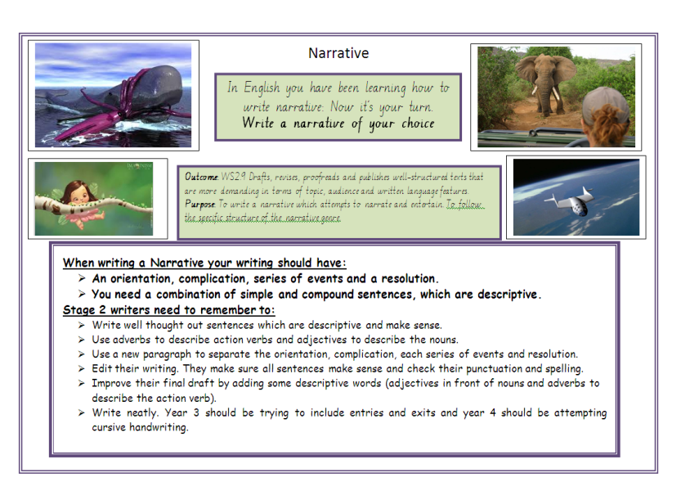
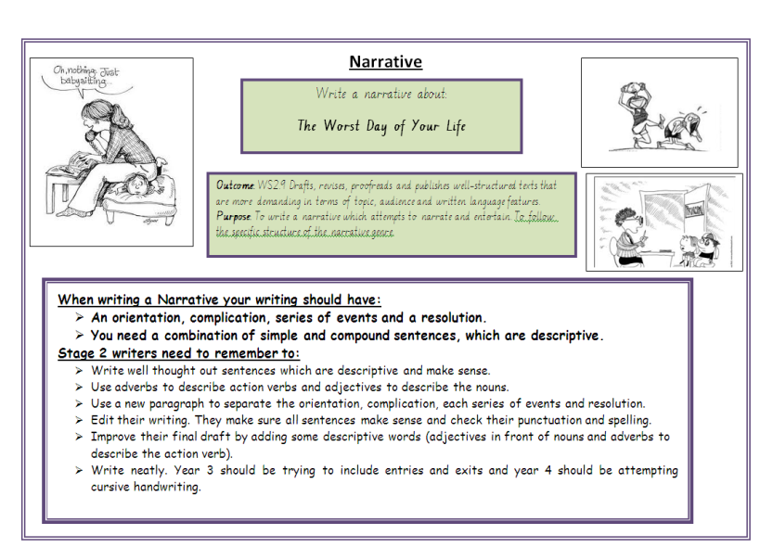

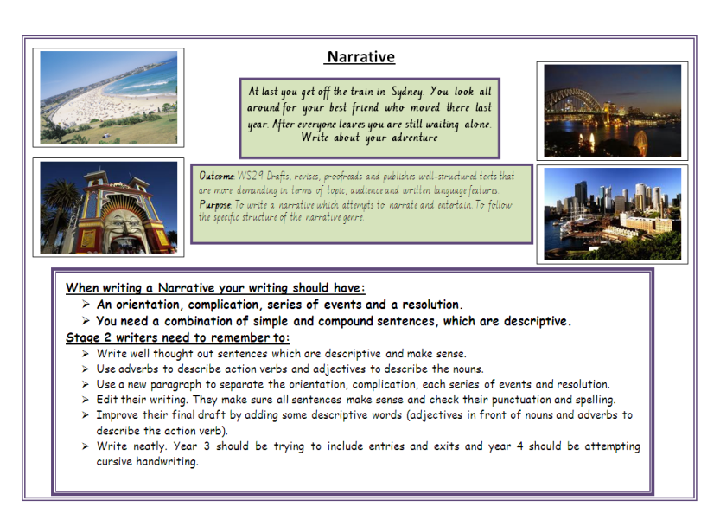
ASSESSMENT OPTIONS – stage 2 teachers to decide each year
