Exposition – Stage 1
Outcomes
WS1.9 Plans, reviews and produces a small range of simple literary and factual texts for a variety of purposes on familiar topics for known readers. | Joint and Independent Writing  - writes a simple statement or short text for different purposes  - combines ideas in writing  - uses a framework to make notes, eg matrix, flowchart, semantic map  - reads own writing aloud and makes some corrections to clarify meaning  - writes elementary descriptions of familiar people and things  - writes short recounts of personal experience  - writes elementary literary texts  - writes basic procedures  - outlines components of something as a first step in writing an explanation of how something works  - writes elementary descriptive information reports  - writes basic explanations  - expresses an opinion in writing  - writes notes from texts  - contributes to joint construction of texts  - uses word processors to create texts.  Audience  - reads own writing to the teacher or a peer  - reads own writing to a variety of audiences and responds to questions seeking elaboration and clarification.  Subject Matter  - chooses appropriate words to label things such as drawings and objects  - begins to explore less familiar topics as a basis for writing activities  - uses heading to indicate the topic of text.  Channel of Communication  - uses drawings to accompany texts where relevant.
WS1.10 Produces texts using the basic grammatical features and punctuation conventions of the text type. | Grammar and Punctuation  - uses adjectives to provide more information about nouns  - uses pronoun references accurately  - uses different types of verbs (action, thinking, seeing, feeling) in own writing  - uses past tense relatively consistently in literary texts  - uses relating verbs to describe and classify in information reports  - uses most common punctuation marks, eg spaces between words, lower-case and capital letters, full stops  - uses creative word play in the writing of literary texts  - uses synonyms in own writing and discusses differences in meaning, eg hurried, raced, rushed  - usually uses capital letters at the beginning of sentences  - usually uses full stops at the end of sentences  - experiments with other punctuation marks, eg commas, quotation marks, question marks.
WS1.11 Uses knowledge of sight words and letter–sound correspondences and a variety of strategies to spell familiar words. | Spelling  - segments word into individual sounds and forms letter that relates to the sound  - isolates and writes the initial, medial and final sound of a word  - exchanges one letter in a written word with a different letter to make a new word  - builds word families  - writes words using blends, letter combinations and long vowel sounds  - spells words using letter names  - writes letters for double consonants, as in hopping  - writes letters for double vowels, as in seed, dead  - draws on knowledge of sight words and high frequency words when writing a text, eg is, are, the, they, she, he, my, school, home  - draws on knowledge of common letter patterns and letter–sound correspondences when writing a text  - reads own writing aloud and makes some corrections to clarify meaning.
WS1.12 Produces texts using letters of consistent size and slope in NSW Foundation Style and using computer technology. | Handwriting  - uses correct pencil grip and maintains correct body position  - forms most letters of the alphabet correctly and appropriately  - tries to write clearly in straight lines, from left to right, using letters of uniform size, shape, slope and spacing  - uses lower- and upper-case letters of consistent size and formation in NSW Foundation Style  - writes letters in proportion to each other  - uses finger movements to control the pencil while sliding forearm across the page.  Using Computers  - experiments with computer functions  - uses functions when editing  - accurately uses words associated with computers, eg keyboard, screen, cursor, mouse, disk, space bar  - enlarges and changes text font  - produces a card or invitation using both graphics and written text  - types sentence/s without assistance  - recognises letters on the keyboard  - uses computer software to create texts  - inserts and ejects a disk  - recognises simple conventions, eg space bar for spaces, shift and caps lock for upper-case letters, tab  - uses computer terminology, eg save, delete, open, exit, print, hard disk, floppy disk, menu, save as, command, caps lock.
WS1.13 Identifies how own texts differ according to their purpose, audience and subject matter. | Purpose  - discusses some of the different purposes for which people write  - examines stages of a text and discusses their functions  - discusses some of the advantages of writing to record information and events  - discusses how familiar examples of writing (including electronic texts) give information in different ways  - discusses some of the different purposes of visual texts such as charts, maps, diagrams, illustrations.  Audience  • states the purpose and intended reader before writing.  Subject Matter  - selects and refines topic before writing.
WS1.14 Identifies the structure of own literary and factual texts and names a limited range of related grammatical features and conventions of written language. | Text Structure  - recognises organisational structure of some literary and factual texts  - recognises the stages of some literary and factual texts  - discusses functions of different stages of a text  Grammar  - talks about synonyms and antonyms in a range of texts  - distinguishes between naming words and doing words  - talks about how adjectives describe nouns, how adverbs tell us more about the verb  - recognises a sentence  - identifies different types of verbs in their own writing, eg saying verb, action verb  - talks about different types of nouns in a story  - talks about action verbs in a recount  - discusses how a description is built up using adjectives, adverbs  - talks about how own procedure has been structured and how action verbs have been used  - identifies key words in own and others’ texts.

Writing Examples (A –E)
Sound Work Sample (C)

Outcome | Organiser | Criteria | Limited E | Basic D | Sound C | High B | Outstanding A
WS  1.9 | Independent Writing | Writes a basic  exposition | Writes key words related to the topic. | Contributes to joint constructions of expositions. | Independently writes a basic exposition | Includes at least two sentences for each section of the text. | Writes detailed paragraphs for each section of the text.
 |  | Planning | Needs sentence starters for each section of the text. | Needs teacher direction to use charts and other resources. | Uses charts, scaffolds as resources as models for own writing. | Uses a simple plan to draft their text. Recognises some errors in own writing. | Uses charts and scaffolds as models, edits own writing and makes some corrections.
WS  1.10 | Grammar | Uses correct  sentence structure | Attempts to write a simple sentence. | Writes well structured simple sentences. | Uses compound sentences with effective conjunctions. | Writes compound and complex sentences using some different conjunctions. | Writes compound and complex sentences with a wide variety of conjunctions.
 | Tense | Accurate tense & number in verb groups. | Attempts to include verbs in text. | Use some different types of verbs. | Mostly uses correct tense and includes some feeling and thinking verbs. | Consistently uses correct tense and uses a variety of feeling verbs. | Uses a range of thinking and modal verbs to indicate degree of definiteness.
 | Cohesion | Cohesive devices | Does not attempt to link the text through the use of connectives. | Uses the same connective throughout. | Uses connectives to order the argument.  Text flows smoothly | Uses a variety of connectives to make clear links between the different sections of the text. | Uses a wide variety of connectives and links the text through repetition and word associations.
 | Punctuation | Uses correct punctuation.. | Attempts to include some forms of punctuation. | Correctly uses most common forms of punctuation. | Usually uses common punctuation e.g. Capital letters, spacing, full stops. | Uses common punctuation and attempts to use other forms e.g. commas, exclamation marks | Uses all forms of punctuation correctly on a consistent basis.
WS  1.11 | Spelling | Spells high frequency words & attempts new words. | Attempts high frequency words. | Spells some high frequency words correctly. Attempts unknown cvc words. | Spells most high frequency words correctly. Uses knowledge of letter combinations and blends to spell unknown words. | Spells all high frequency words correctly. Begins to use knowledge of letter patterns and spelling rules to spell unknown words. | Spells all high frequency and more difficult words correctly. Uses knowledge of letter patterns and spelling rules to spell unknown words.
WS 1.14 | Text Structure | Organisational  structure of  exposition | Lack of structure in the text. | Has an opening statement and at least one argument to support it. | Contains an opening statement, at least 2 arguments to support their statement and a concluding statement. | Contains an opening statement, at least 3 arguments to support their statement and a concluding statement. | Contains an opening statement with 4 to 5 meaningful arguments to support their statement as well as a concluding statement.
 |  | Paragraphs | Does not attempt to use paragraphs. | Attempts to use paragraphing but paragraphs contain one sentence or make it difficult to follow the argument. | Attempts to use paragraphs to organise the text. Argument is easy to follow. | Segments most of the text into paragraphs that assists the reader to follow the argument. | Each paragraph focuses on one argument and contains all related information.
 |  | Punctuation | Attempts to include some forms of punctuation. | Correctly uses most common forms of punctuation. | Usually uses common punctuation e.g. Capital letters, spacing, full stops. | Uses common punctuation and attempts to use other forms e.g. commas, exclamation marks | Uses all forms of punctuation correctly on a consistent basis.
 | Ideas | Elaboration | Arguments are unrelated to topic. | Arguments are few or irrelevant and not elaborated on. | Shows some elaboration which links directly to their argument. | Includes relevant, substantial elaboration on each argument presented. | Contains relevant arguments which are clearly defined, sequential and elaborated on in detail.
EXPOSITION
My Exposition Check List  - I have used capitals and fullstops.  - I have an opening statement.  - I have at least 2 arguments.  - I have a concluding statement.  - I have checked my spelling  - I have used connecting words - and, but, because  - I have used feeling words –very, really, mostly  - I have used thinking words - I believe, I agree, I think  - I have organised my writing into paragraphs.  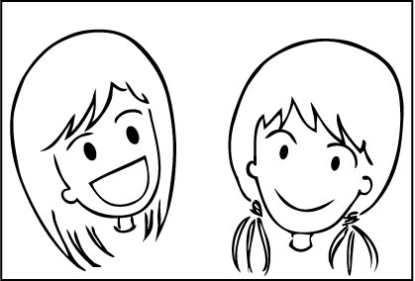 |  | My Exposition Check List  - I have used capitals and fullstops.  - I have an opening statement.  - I have at least 2 arguments.  - I have a concluding statement.  - I have checked my spelling  - I have used connecting words - and, but, because  - I have used feeling words –very, really, mostly  - I have used thinking words - I believe, I agree, I think  - I have organised my writing into paragraphs.

STAGE 1 – Exposition Assessment (even years)

STAGE 1 – Exposition Assessment (odd years)

Year 1 Exposition Task
Task: Write an argument about whether or not children should have to wear a helmet when riding a scooter. Remember to state your opinion in your introduction, then follow with at least two supporting arguments. Finish your exposition with a concluding statement.
Outcome: Plans, reviews and produces a small range of simple literary and factual texts for a variety of purposes on familiar topics for known readers.
Purpose: To write an exposition that argues a case for or against a particular position or point of view.

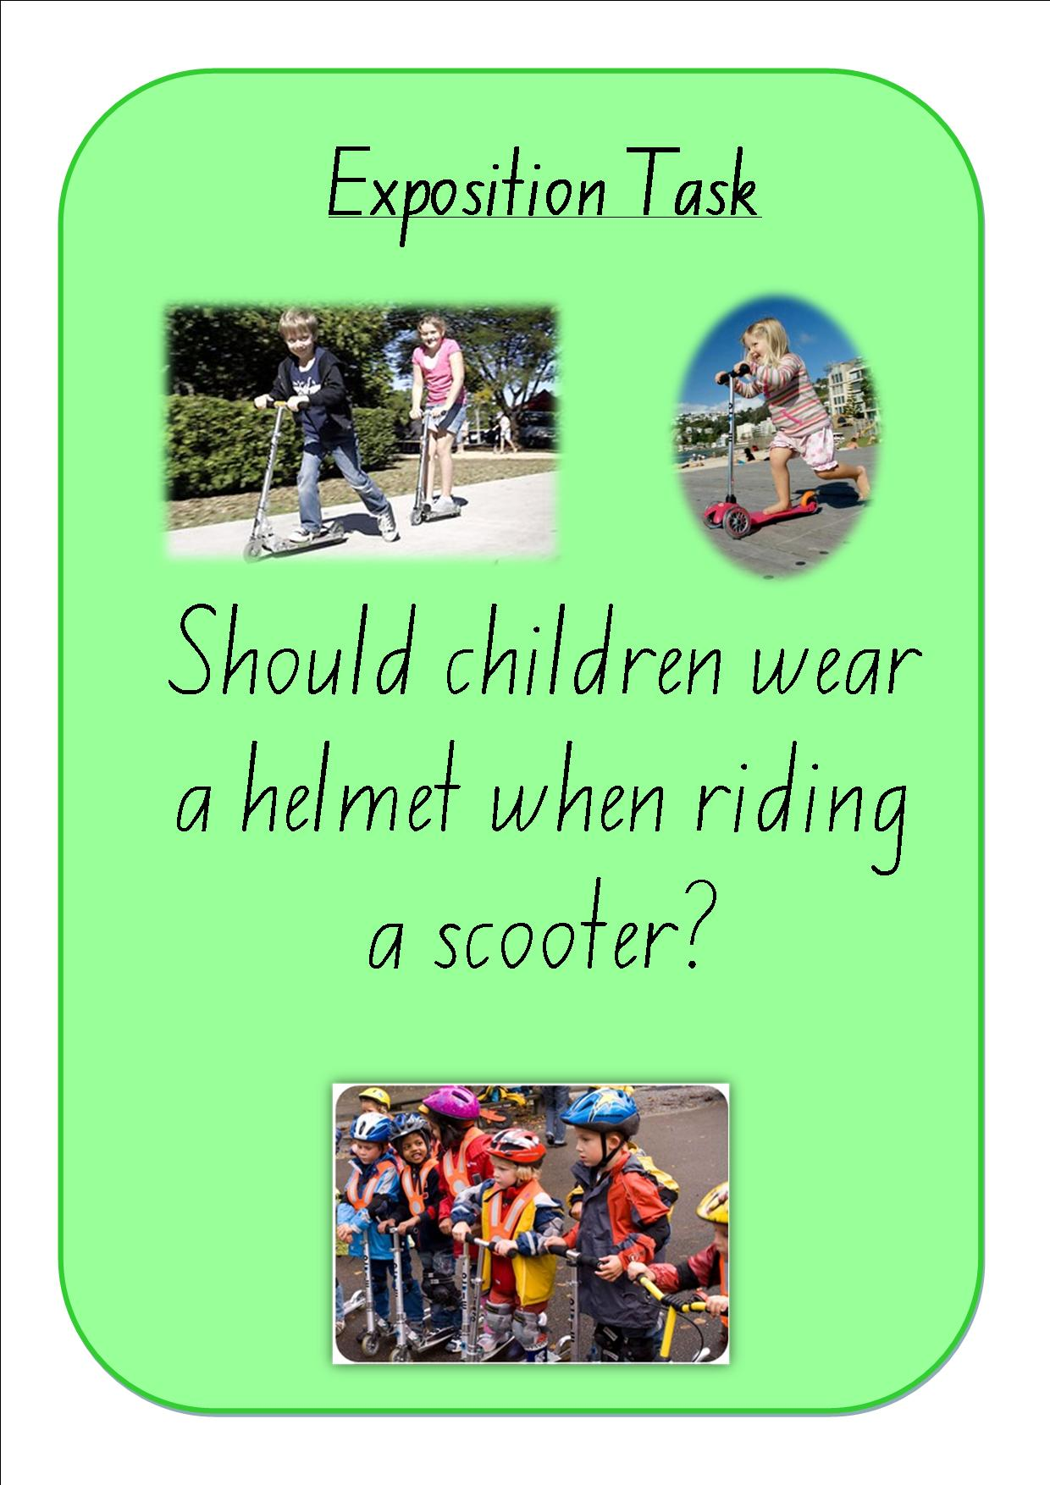

When writing an exposition your writing should have:
- A ‘statement of position’, ‘arguments’ and a ‘reinforcement of position statement’.

Stage 1 writers need to remember to:
- Use simple and compound sentences with correct basic punctuation.
- Use some connectives to organise text, eg firstly, secondly.
- Use action, relating and feeling verbs, eg They are Australian animals; Many people like koalas, I think that...
- Give extra information about each idea.
- Reread their writing and make corrections.

Year 2 Exposition Task
Task: Write an argument about why children should or should not have to go to bed early. Remember to state your opinion in your introduction, then follow with at least two supporting arguments. Finish your exposition with a concluding statement.
Outcome: Plans, reviews and produces a small range of simple literary and factual texts for a variety of purposes on familiar topics for known readers.
Purpose: To write an exposition that argues a case for or against a particular position or point of view.

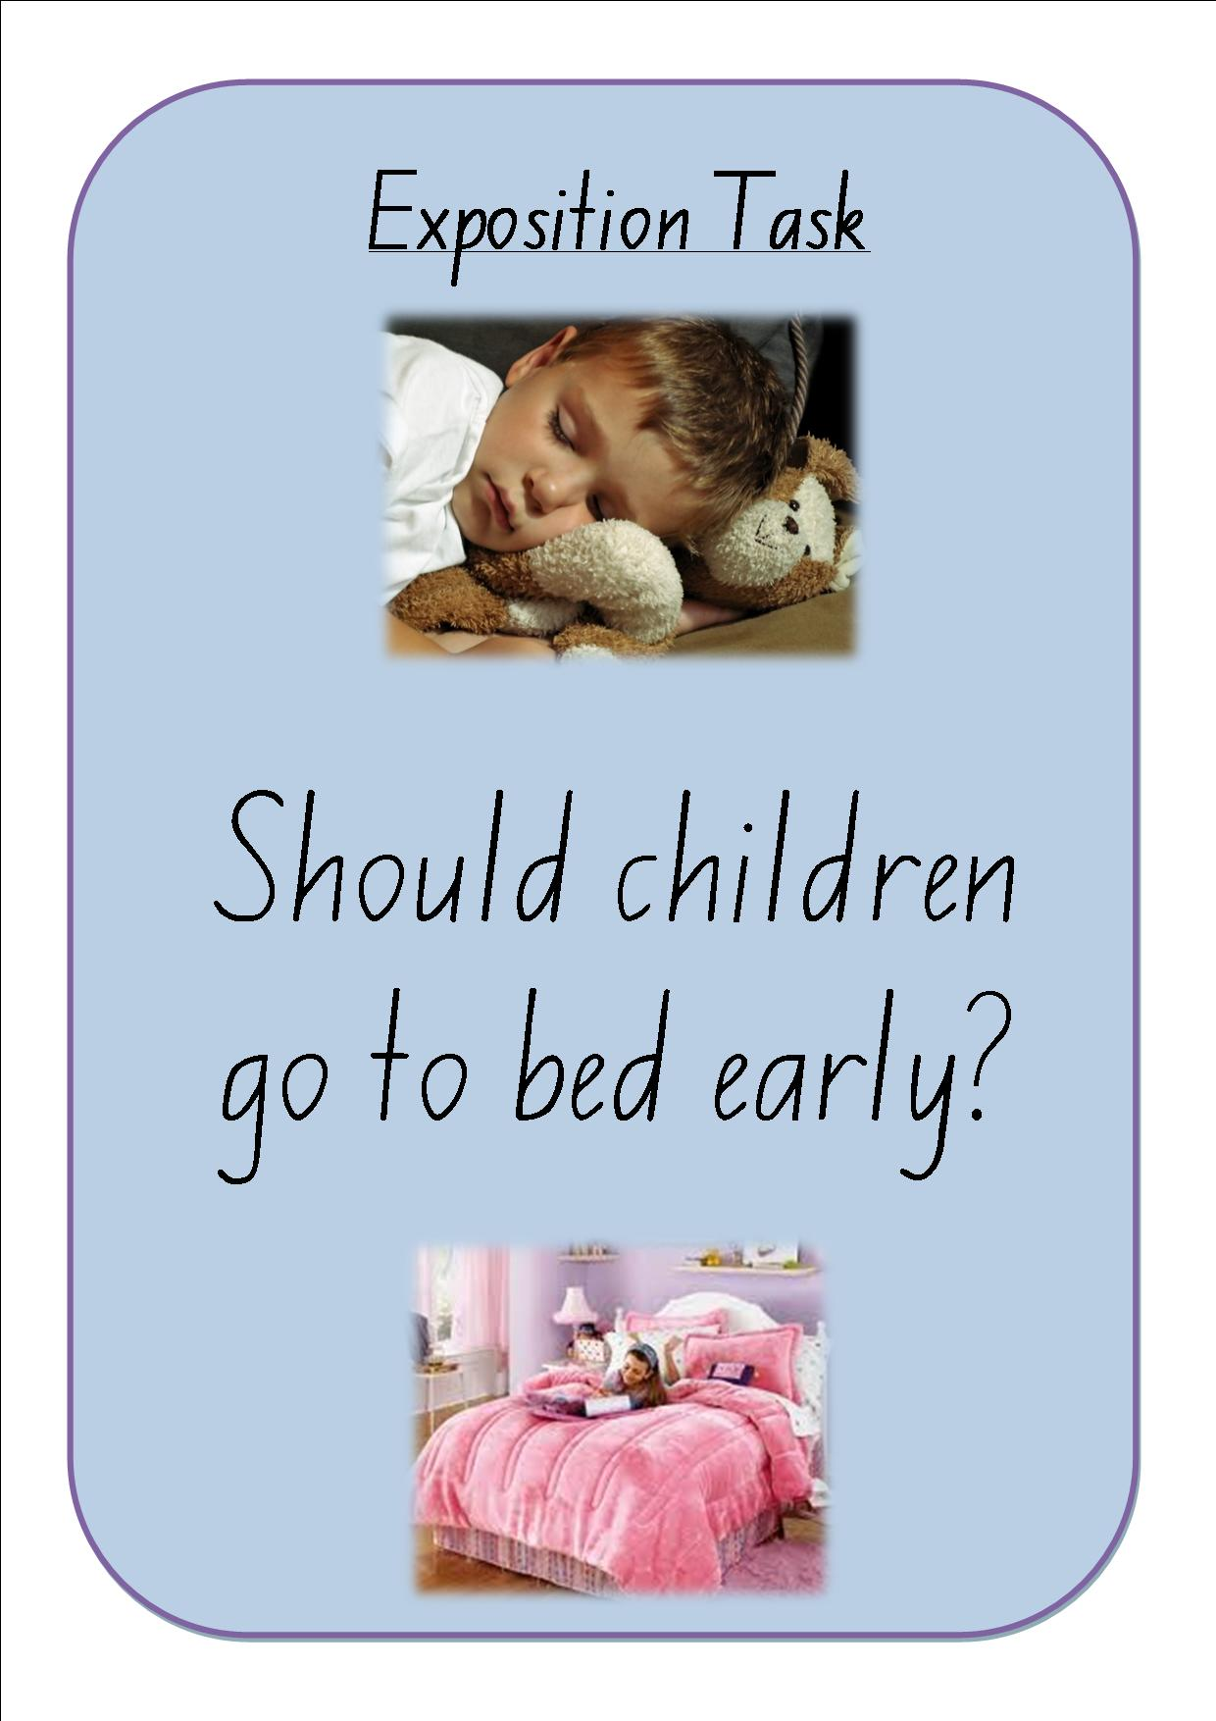
When writing an exposition your writing should have:
- A ‘statement of position’, ‘arguments’ and a ‘reinforcement of position statement’.

Stage 1 writers need to remember to:
- Use simple and compound sentences with correct basic punctuation.
- Use some connectives to organise text, eg firstly, secondly.
- Use action, relating and feeling verbs, eg They are Australian animals; Many people like koalas, I think that...
- Give extra information about each idea.
- Reread their writing and make corrections.

Exposition Task
Task:
Outcome: Plans, reviews and produces a small range of simple literary and factual texts for a variety of purposes on familiar topics for known readers.
Purpose: To write an exposition that argues a case for or against a particular position or point of view.

When writing an exposition your writing should have:
- A ‘statement of position’, ‘arguments’ and a ‘reinforcement of position statement’.

Stage 1 writers need to remember to:
- Use simple and compound sentences with correct basic punctuation.
- Use some connectives to organise text, eg firstly, secondly.
- Use action, relating and feeling verbs, eg They are Australian animals; Many people like koalas, I think that...
- Give extra information about each idea.
- Reread their writing and make corrections.

